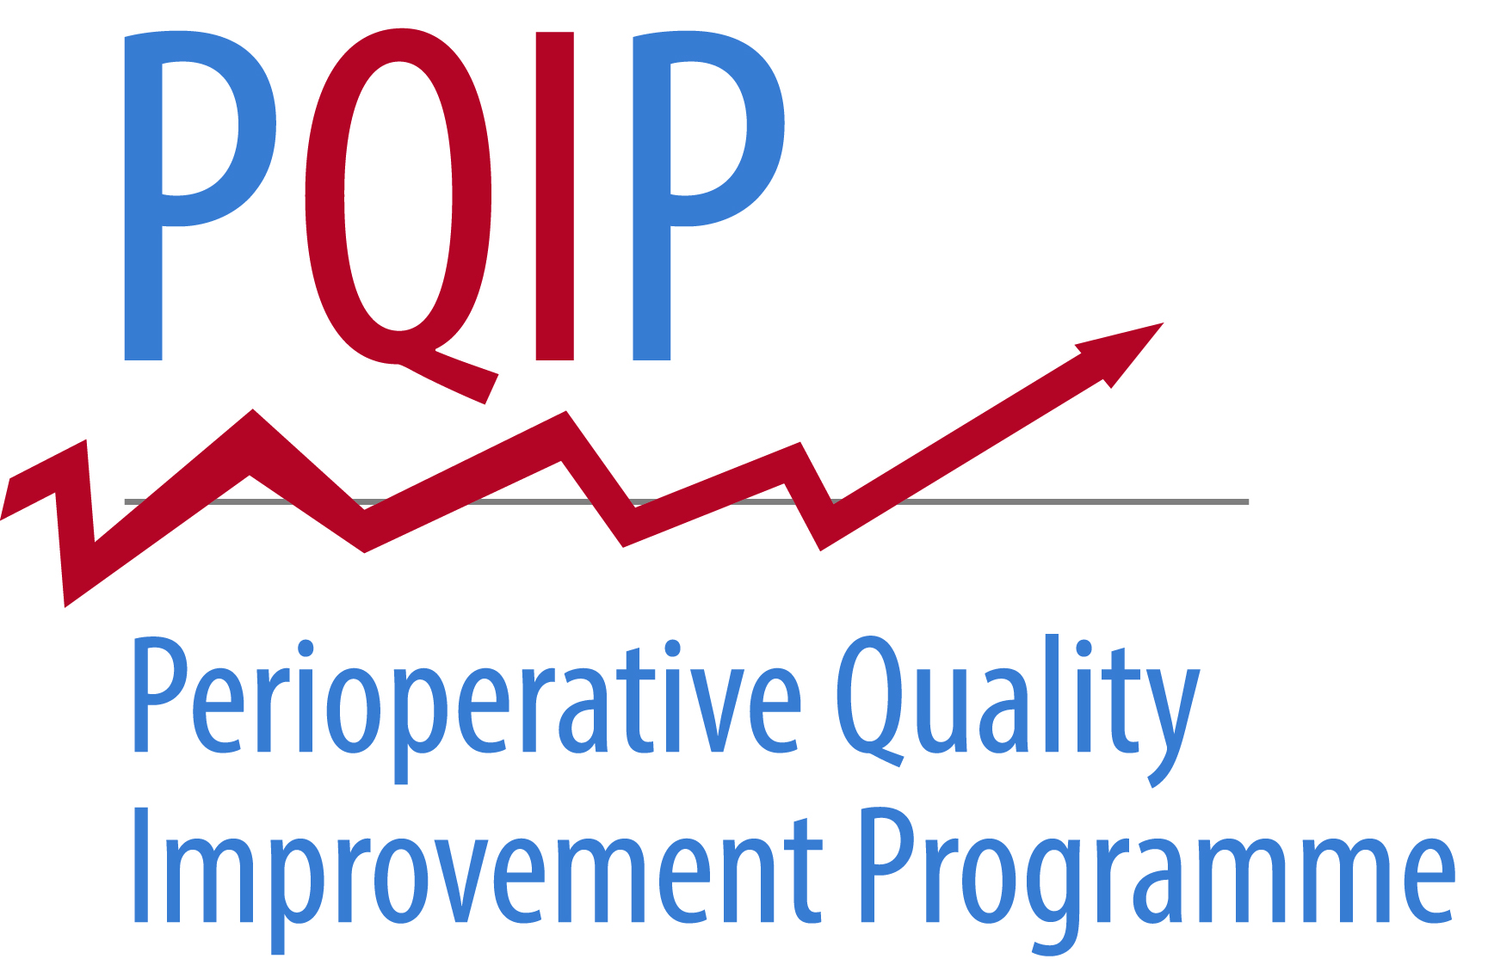
Site logo here

<date>
<patient address>

Dear <patient name>

<Hospital name> is taking part in a national research project aimed at improving care for patients having surgery, called the Perioperative Quality Improvement Project (PQIP. We would like to invite you to take part. You will find enclosed a Participant Information Sheet, which explains the study, what it would involve for you, and how it can improve patient care.

Once you have had a chance to read the information, you will be able to discuss it with us when you next come to hospital or our research team may contact you beforehand via telephone or email. If you wish to discuss it with us sooner please do not hesitate to contact us using the details below.

Please be assured that your decision about whether or not to take part in this project will not affect the care you receive from < hospital >.

Thank you for your time,

Yours sincerely

<name of sender>
<role of sender>
<site name>
<phone number>

Study Name: Perioperative Quality Improvement Project (PQIP)
Principal Investigator at <site name>: <local PI>

